**ASSIGNMENT-1**

-submitted by **Dinesh kumar Kunchala**

Date: 09/04/2023

1.Step1:Install Java 8 or above and eclipse.

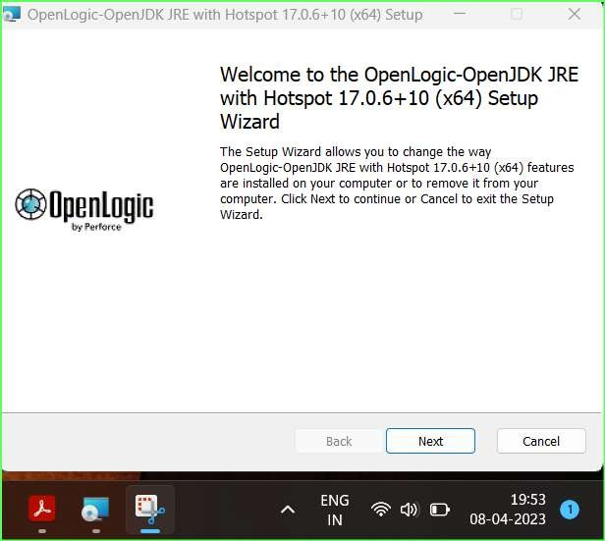Go to <https://www.openlogic.com/openjdk-downloads>url and install the version of java .

to verify the successful installation of java run below command.

**$ java—version** on cmd.

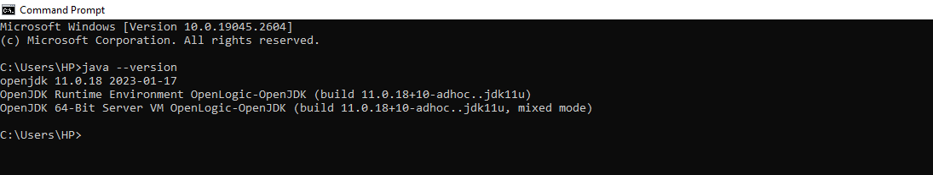

To install eclipse go to [https://www.eclipse.org/downloads](https://www.eclipse.org/downloads/)/ url and download latest version eclipse.The installer window will be show as below image.Select the **Eclipse ide for java developers** and install.

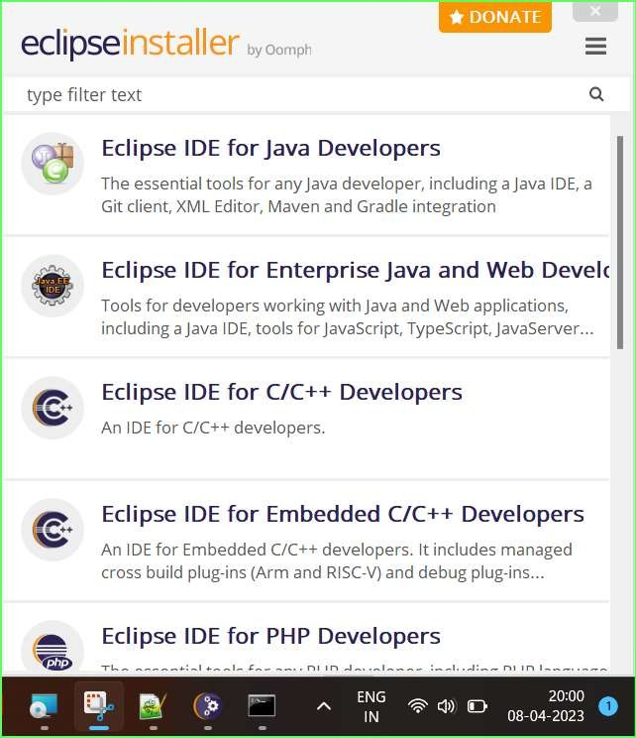

Step2: create a java dynamic project.

In Eclipse Click on **File->new->Dynamic Web Project.**

Give the project name and select Target runtime as Apache Tomcat v9.0 or above.

Step3: Create an Index.html file.

Click on **src->main** and right click on webapp select **New->HTML File**.

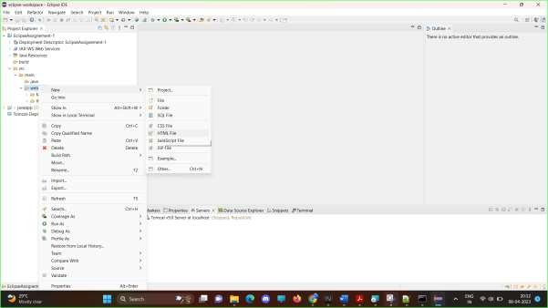

Enter the below code in Index.html File and save it.

<!DOCTYPE html>

<html>

<head>

<meta charset=*"ISO-8859-1"*>

<title>Hi</title>

</head>

<body>

<h1>Hi Dinesh</h1>

</body>

</html>

Step4: Install the tomcat9 server.

Go to <https://tomcat.apache.org/download-90.cgi>and selec[t 32-bit/64-bit](https://dlcdn.apache.org/tomcat/tomcat-9/v9.0.73/bin/apache-tomcat-9.0.73.exe)

[Windows Service Installer](https://dlcdn.apache.org/tomcat/tomcat-9/v9.0.73/bin/apache-tomcat-9.0.73.exe) [(pgp,](https://downloads.apache.org/tomcat/tomcat-9/v9.0.73/bin/apache-tomcat-9.0.73.exe.asc) [sha512](https://downloads.apache.org/tomcat/tomcat-9/v9.0.73/bin/apache-tomcat-9.0.73.exe.sha512)).

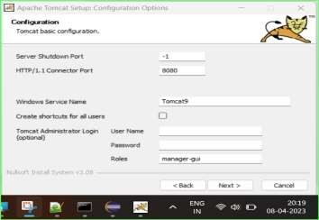

Step5: Deploy to the application on tomcat9 Server.

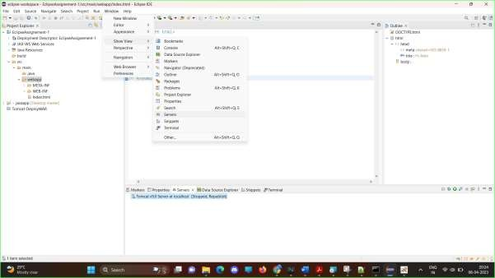

Step6: Start the server.

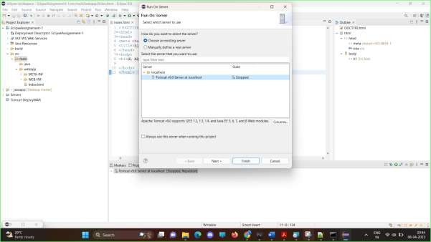

Step6: start the server.

Right click select **Run as->Run on Server**.

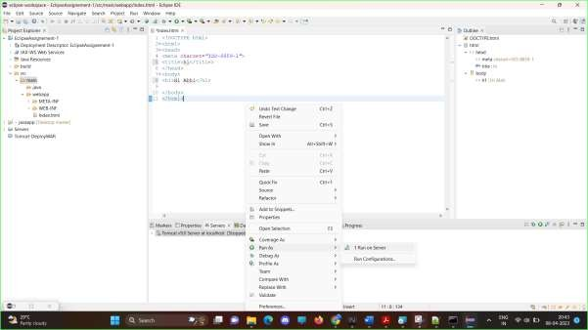

Step7: Verify the application is running.

Open port in which tomcat is set to run [by default localhost:8080]

